  www.hba.org.my | SEMINAR  Strata Property Management  Who’s in Charge?  22nd March, 2008 (Saturday) at Kuala Lumpur Convention Centre (KLCC) at 2.00 pm – 6.00pm

Seminar Sponsor:
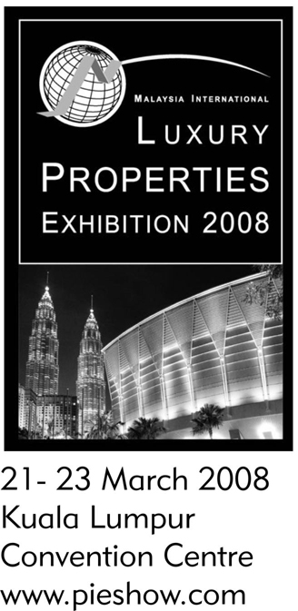 | The National House Buyers Association (HBA) is organising a Seminar with speakers, Ms Viola De Cruz and Mr Kuna Sekaran, Advocates & Solicitors, on Saturday, 22nd March, 2008 (Saturday) at Ground Floor, Hall 4, Hospitality Lounge, Kuala Lumpur Convention Centre, at 2.00pm – 6.00pm.  Seminar Objectives  This Seminar offers participants an opportunity to better understand the roles of the different bodies – Joint Management Body (JMB), Management Corporation (MC) and Commissioner of Buildings (COB), developers and managing agents in the management of residential strata properties such as condominiums, apartment, flats & townhouses; hear past Court Decisions that relates to the Strata Titles Act, 1985; its’ amendment 2007 and highlights of the Building & Common Property (Maintenance and Management) Act, 2007; its’ implication etc.  There will be a LUCKY DRAW of Maps (sponsored by Ho Chin Soon Research and United Overseas Bank (UOB) worth RM7000.00 at the end of the Seminar

PROGRAM |  | FEE  RM 200 per participant.  Register with payments by 16th March 2008 to enjoy a RM25.00 discount
1.30 pm | Participants registration
2.00 pm | Opening address by YBhg Brig Gen (R) Datuk Goh Seng Toh. Hon. Vice President of HBA. | Payment Method  Payment in favour of the ‘National House Buyers Association’ to EON Bank Account Number: 00-301-000-1011-9  Confirmation of participants will be send by fax if a fax number is provided.
2.15 pm | Introduction & Welcome address by the Moderator, Chang Kim Loong AMN, Hon.Secretary-General of HBA | REGISTRATION FORM  Please register the following participant(s) for this Seminar.  Participant/s:  1. ____________________________________  2. ____________________________________  3. ____________________________________  4. ____________________________________  No of participants : ______ Fee : RM________  Organisation:___________________________  Contact Person _________________________  Mobile phone: __________________________  Tel (O):______________ Fax:____________  Email:_________________________________  Signature: ________________________  Date:
2.30 pm | “Formation of JMB”  under the Building & Common Property (Maintenance & Management) Act, 2007;  ‘Role & Powers of COB”  by Viola De Cruz LLB, Barrister-at-Law, Advocates & Solicitors
3.30 pm | Questions & Answers
4.00 pm | Break
4.15 pm | “Formation, role & duties of MC, ” under the Strata Titles Act, 1985 (amended 2007)  by Kuna Sekaran LLB, CLP  Advocates & Solicitors
5.15 pm | Questions & Answers
6.00 pm | Lucky Draw | Please fax your registration form & bank-in advice slip to:  Fax No: 03-22601803  Email to us at info@hba.org.my for written confirmation OR  For Details of the Seminar, please contact the HBA Secretariat at Tel No: 012-2524287 / 012 3345676
6.15 pm | End

